 ***Faculty of Computing & Information Technology***

**CC-215-L: Database Systems Lab**

**BSCS Morning - Fall 2022, Semester Spring 2024**

**LAB – 01**

**Lab Instructor:** **Mam Sanam Ahmad**

***Allowed time: 90 mins.***

**Topics:**

1. Select
2. Where
3. Arithmetic and logical operators

**Objectives:**

1. Installation & Set ting Up Lab environment
2. Basic Select, where Statements

***Instructions:***

1. Gossips are not allowed.
2. Teacher assistants are for your help, so be nice with them. Respect them as they are teaching you. Raise your hands if you have some problem and need help from TA. Avoid calling them by raising your voice and disturbing the environment of Lab.
3. TA may deduct your marks for any kind of ill-discipline or misconduct from your side.
4. Evaluation will be considered final and you cannot debate for the marks. So, focus on performing the tasks when the time is given to you.
5. Paste the query as well as result table screenshot as a result of each task

**Task 01: ________________________ (12 Marks)**

1. Installation of MySql setup
2. Uploaded The Tables (EMP,DEPT , SALGRADE , PUCIT)

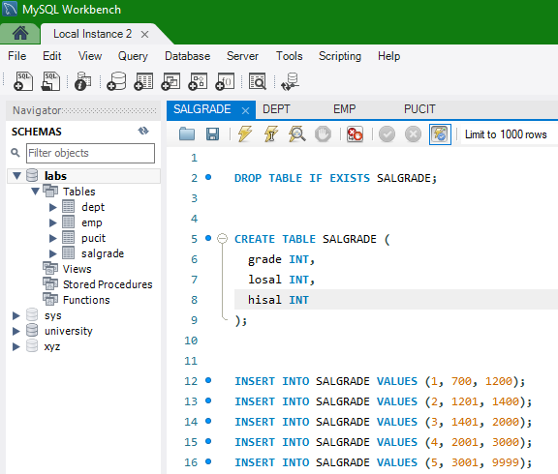

**SELECT** Statement

The SELECT statement is used to retrieve data from one or more tables in a database. The basic syntax of a SELECT statement is:

**SELECT * FROM table_name;**

Run These Queries:

**Select * from EMP;**

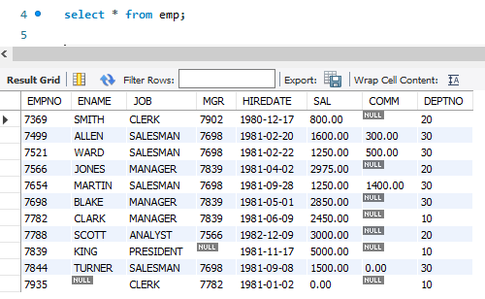

**Select Deptno from Dept;**

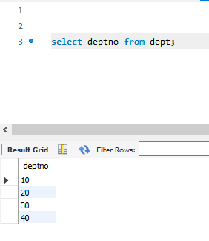

### WHERE**Statement**

The WHERE clause is used to filter records. It helps to select only those rows that satisfy a given condition. The syntax of a WHERE clause is:

**SELECT column_name1, column_name2, ...**

**FROM table_name**

**WHERE condition;**

**Condition**

The condition that must be met for a row to be selected.

Run These Queries:

**SELECT ENAME, JOB, SAL FROM EMP WHERE SAL > 2000;**

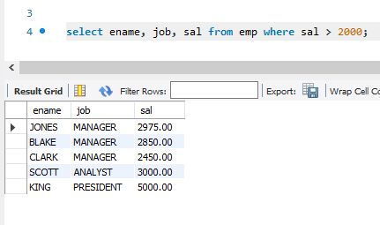

**SELECT * FROM DEPT WHERE LOC=’Boston’;**

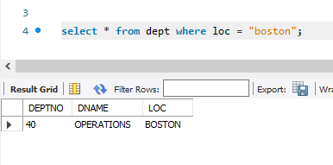

### ****Task 2 (13 Marks)****

1. Retrieve all student names from the PUCIT table.

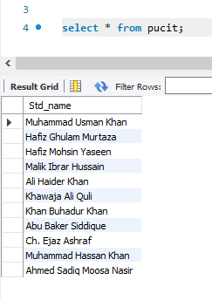

1. Retrieve employee names and their job titles from the EMP table.

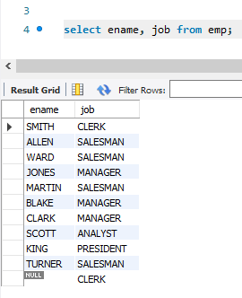

1. Retrieve department names and locations from the DEPT table.

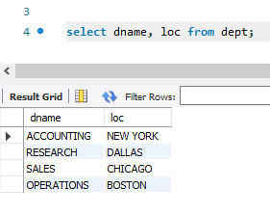

1. Retrieve the grades and salary ranges (losal, hisal) from the SALGRADE table.

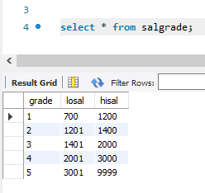

1. Retrieve all employees from the EMP table who are managers.

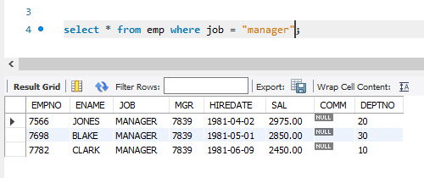

1. Retrieve employees whose salary is greater than 3000.

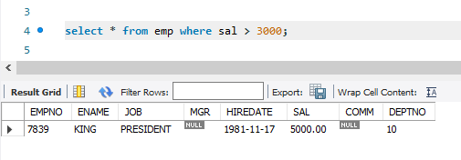

1. Retrieve employee names and calculate their annual salary assuming the current salary is monthly.

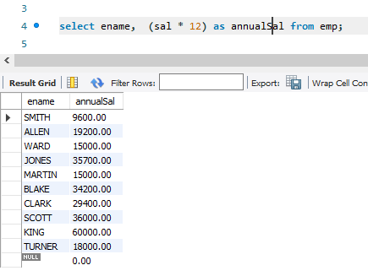

1. Retrieve employee names and subtract 500 from their salary.

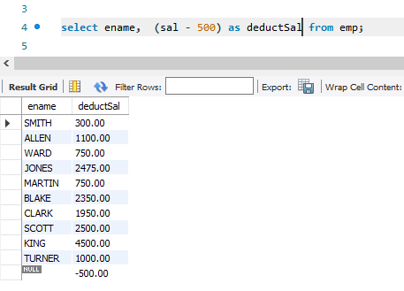

1. Retrieve employees who work in department number 30 and have a salary greater than 2000.

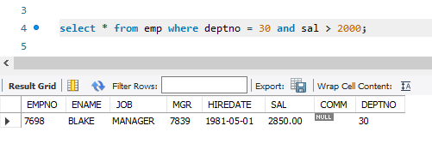

1. Retrieve employees who are either salesmen or clerks.

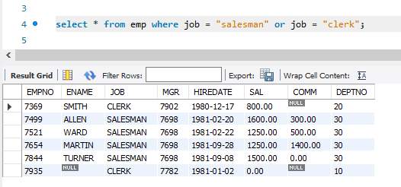

1. Retrieve employees who work in department 20 or have a salary greater than 2500.

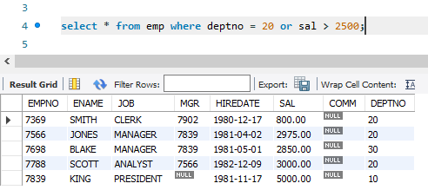

1. List the employee-manager working under the having id=7566.

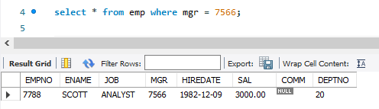

1. List the employees that are not clerks.

